In-Class Exercise: Demonstrating Meiosis Using Manipulatable Chromosomes and Cells
Mary F. Durham*
School of Biological Sciences
University of Nebraska-Lincoln
Lincoln, NE 68588

*Corresponding Author: mdurham2@unl.edu
Accepted for publication May 15, 2015
Citation:
Durham, Mary F. (2015). Demonstrating Meiosis Using Manipulatable Chromosomes and Cells. Genetics Society of America Peer-Reviewed Education Portal (GSA PREP): 2015.002; doi: 10.1534/gsaprep.2015.002

Synopsis:
This resource describes an in-class, hands-on, manipulative modeling exercise designed for students to complete individually but work through in small groups. The activity was designed for use in discussion sections of approximately 30 students each, but it has also been used successfully in lecture sections of up to 90 students and it can also be used in larger lecture courses. This activity is designed to allow students to visualize and demonstrate meiosis in a diploid cell by manipulating a simplified three-dimensional model of chromosomes in a model germ cell. The implementation of this activity is designed to appeal to visual, auditory, and kinesthetic learning styles. Meiosis is consistently a challenging process for students to grasp, likely because it occurs on a microscopic and molecular level that is abstract to student thinking. By allowing each student to manipulate individual model chromosomes in a model cell, the activity makes meiosis a tangible and accessible concept to students in a way that allows students to make sense of the abstract properties of meiosis. This activity can specifically incorporate challenging aspects of meiosis and processes that occur during or as a result of meiosis that are often difficult for students to understand or visualize. In particular, this activity has been used to demonstrate crossing over, ploidy of the cells in different stages of meiosis, the number of chromosomes, chromatids, and DNA molecules at different stages of meiosis, how individual maternal and paternal alleles travel to individual gametes, how meiosis leads to genetic variation, how mistakes in meiosis can result in aneuploidy, and to practice quantitative skills by calculating chromosome or DNA molecule numbers at different stages of meiosis, with and without the occurrence of nondisjunction.

Approach/Method: (Instructor Guidelines)
Introduction:
Meiosis is a major biological process that is essential for student understanding of heritability in sexually reproducing organisms. The main learning objective of this activity is for students to demonstrate meiosis by manipulating and modifying model chromosomes and cells. Students will also be able to quantify chromosomes, chromatids, and DNA molecules at each stage of meiosis, follow a single allele on a chromosome through the process of meiosis, compare and contrast mitosis and meiosis, visualize how meiosis leads to genetic variation in gametes, and recognize how mistakes in meiosis lead to aneuploidy. Students work through the steps of meiosis in teams, completing the manipulative modeling individually. Students are guided as a class by the instructor through each step of the process with particular focus on what is happening to the chromosomes and DNA molecules at each stage. Depending on the focus of the course, parts 4 and 5 of the activity may be considered optional.
Estimated time: 30-50 minutes
Pre-Class Assignment:
It is recommended that students are given a priming activity to complete prior to class to prepare them to apply the concepts related to meiosis to the demonstration. A suggested assignment is an open-ended or short answer worksheet aligned to textbook reading material followed by a short quiz at the beginning of class or just prior to class. An example worksheet aligned to Freeman et al., Biological Science 5th edition (2013) is included in the supplementary materials.
Part 1: In-Class Priming (7-10 minutes)
Ask the students to draw a schematic diagram of meiosis starting with a cell in the G1 stage of the cell cycle and progressing through meiosis. Ask students to add as much detail as possible and to pay close attention to what is happening to the chromosomes in the cell(s). First, have students work individually with no textbook or notebook resources. This allows students to become aware of what they do not yet know well. Circulate around the room to gauge the point at which students get “stuck” and their writing slows or stops, often within five minutes. At this point, allow students to work in teams of approximately four students with diverse intellectual abilities and backgrounds. Ask students to build upon their diagrams based on input from their peers, but still not using any resources other than their peers. Circulate around the room to answer questions or offer suggestions of features to add to student diagrams. When student discussion about the activity diminishes, often after 3 minutes, allow students to reference their notebooks or textbooks to fill in any crucial missing aspects of their diagrams. Have students use only this diagram to guide them through the class activity. Clearing their workspace of everything except this diagram, the companion worksheet, and a mode of taking notes is helpful.
Part 2: Demonstration: Prior to Meiosis (3-5 minutes)
Distribute the companion worksheet and the demonstration materials. Each student should receive two matching pairs of gummy worms (e.g. two red worms and two green worms) and a four-fold napkin. If desired, plasticware knives may also be distributed for cutting the worms during crossing over, but this is not required if students are permitted to bite the worms. Students may choose their own pairs of worms from a bag or worm “packets” containing the two pairs of worms in a plastic sandwich bag may be prepared ahead of time.
Identify the worms as chromosomes and the napkins as cells. Explain to your students that this organism is a diploid organism. Ask the students to begin by putting their cells in the beginning of the G1 stage of the cell cycle.
For this and each step in the activity, allow time for students to arrange their chromosomes and cells, and to discuss their choices with their teams. Remind students to use the outlines they designed at the beginning of class to guide them. Circulate around the room and find examples of differently arranged chromosomes and cells and ask students to explain why they arranged their cells or chromosomes in this way. When possible, ask students to reason through why certain arrangements could lead to undesirable consequences (e.g. nondisjunction or cell death), and why other arrangements are ideal for the survival or success of the eventual gamete or its precursor cells. In a large lecture hall, it may be helpful to show pictures of common student arrangements, both correct and incorrect, on a projected slide when asking students to discuss their responses so that the whole class can visualize and consider the arrangements being discussed. Some common student responses to some steps are included later in the instructor guide.

Guide the class conversation to lead to a cell in early G1, as displayed by the completely folded napkin containing one worm of each color:
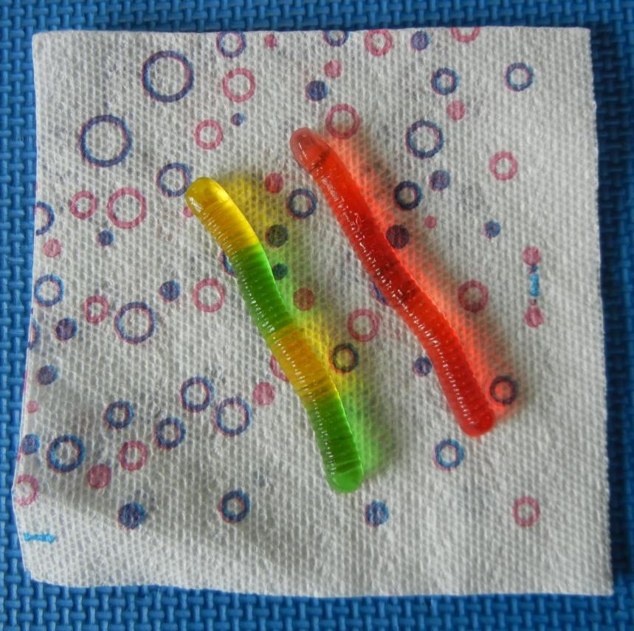

After discussing different student responses, take time to discuss the chromosome number (n) of their cell, the ploidy, the total number of chromosomes, and the total number of DNA molecules. Have students fill in the chart on the companion worksheet. It may also be helpful to show a cell with an n>1 using other gummy or candy items, as shown below to illustrate what multiple chromosomes might look like, how different chromosomes contain different genes that code for different traits, and how homologous chromosomes are similar compared to non-homologous chromosomes:
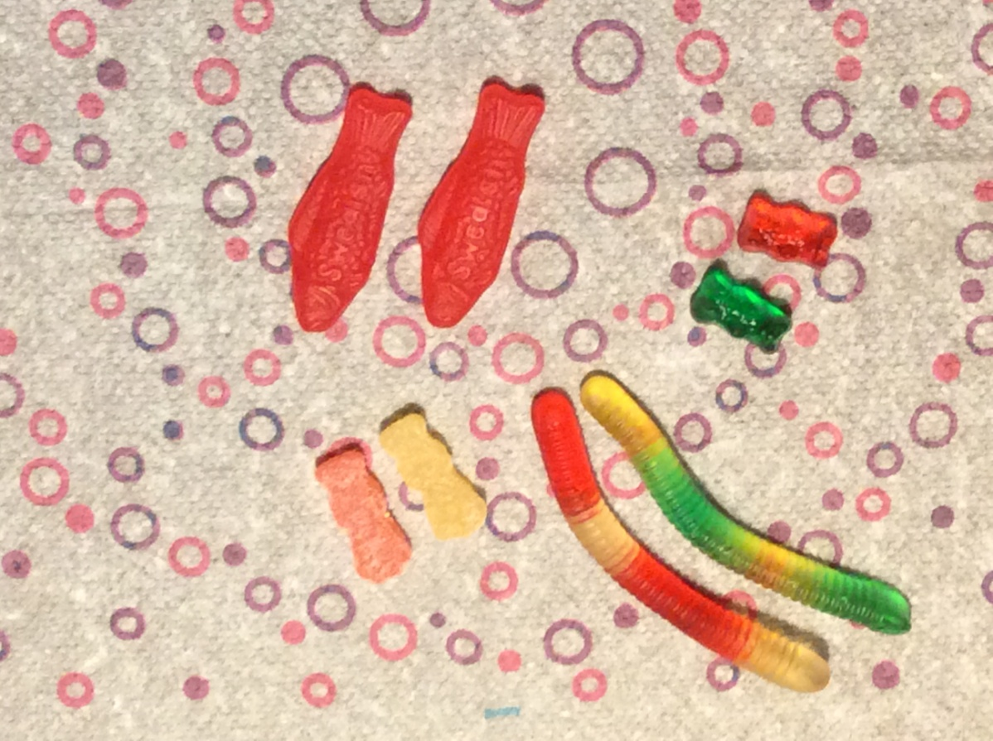

Next, take a few moments to discuss what types of cells undergo meiosis and where in the student’s body meiosis occurs. Next, have the students assign one chromosome as inherited from their father and one chromosome as inherited from their mother. Discuss how traits such as “yellow hair” or “red hair” can be passed on to offspring through chromosome heritability, using the worms to guide the conversation. It is important to discuss with your students that this example is a fictional example that does not accurately reflect the complex inheritance of hair color, body features, or foot features. This is a good time to discuss the differences between Mendelian and non-Mendelian inheritance.
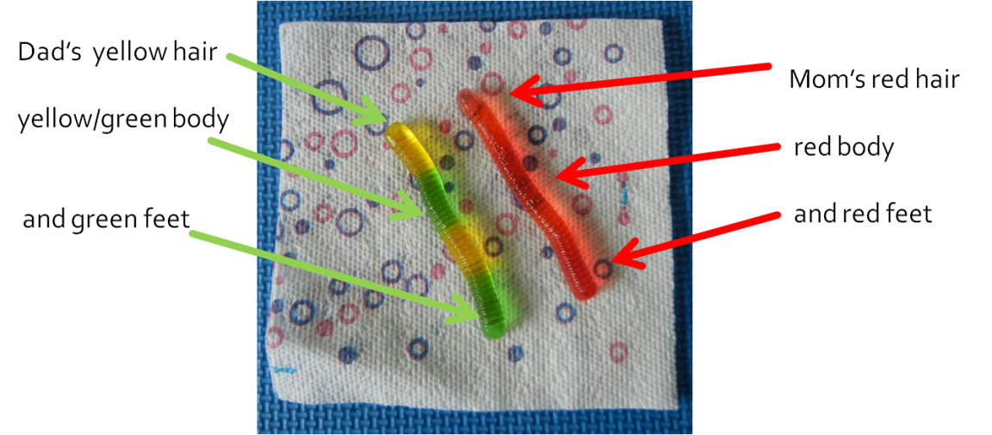
Ask students what happens to the cell next, and if it is not offered, lead students to DNA synthesis/replication as the next stage of the cell cycle. Ask the students to complete DNA synthesis in their cells. Worms should be arranged in replicated, X-shaped chromosomes of identical worms, or sister chromatids. To join chromatids at the centromere, have students either bite or cut a very small nip out of the side of each worm (the inside side when the worms are aligned as a pair), and press the open, sticky areas of the worms together. If desired, discuss features of the centromere as appropriate to your course.
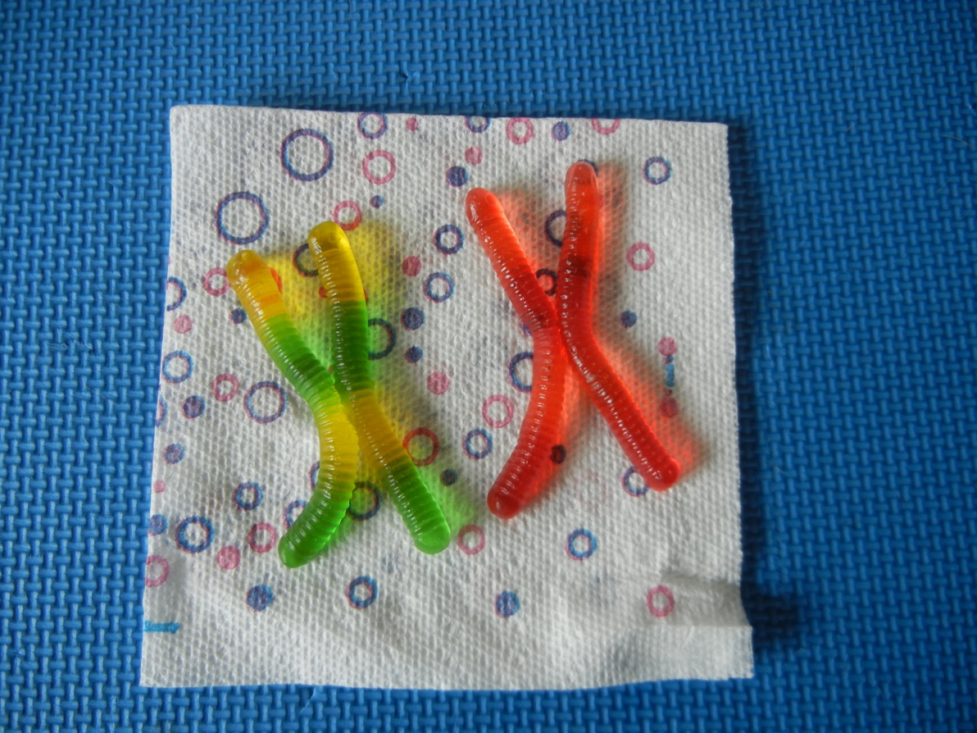
Have the students complete the “S-phase” portion of the table while discussing the ploidy, chromosome number, total number of chromosomes, total number of chromatids, and total number of DNA molecules. Students often struggle with ploidy at this point, so it is helpful to spend time comparing a replicated versus non-replicated chromosome and how the total number of chromosomes and ploidy has not changed even though the number of DNA molecules has doubled.
Next ask your students to have their cells undergo the G2 stage of the cell cycle, which consists of cell growth as indicated by the unfolding of the napkin.
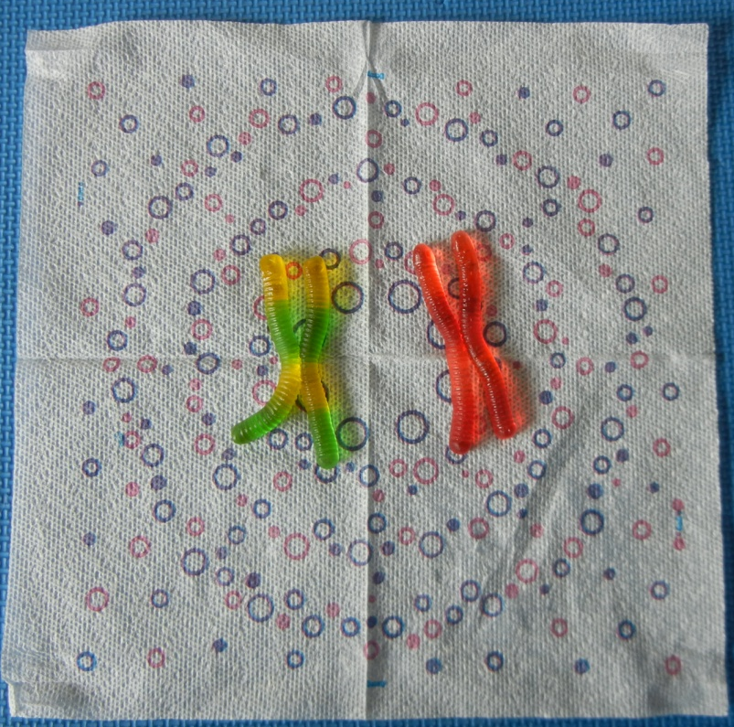
Explain to the students that now the cell is ready to leave the cell cycle and undergo meiosis instead of mitosis.
Part 3: Demonstration: Meiosis (10-15 minutes)
Although the focus of this activity in the past has not been on the breakdown of specific properties and occurrences of each individual stage of meosis (prophase, metaphase, anaphase, telophase), the activity can easily be adapted to include these aspects. For the courses that this activity was used in, the primary focus was on major chromosomal and division events in meiosis, and this guide will proceed as such.
Now that the cells are prepared for meiosis, the cells can begin the process of meiosis. Discuss how homologous chromosomes pair up and form tetrads. Ask your students to put the cells in late prophase I, when tetrads are formed. For illustrative purposes of the activity, have chromosomes overlap only for one pair of non-sister chromatids.
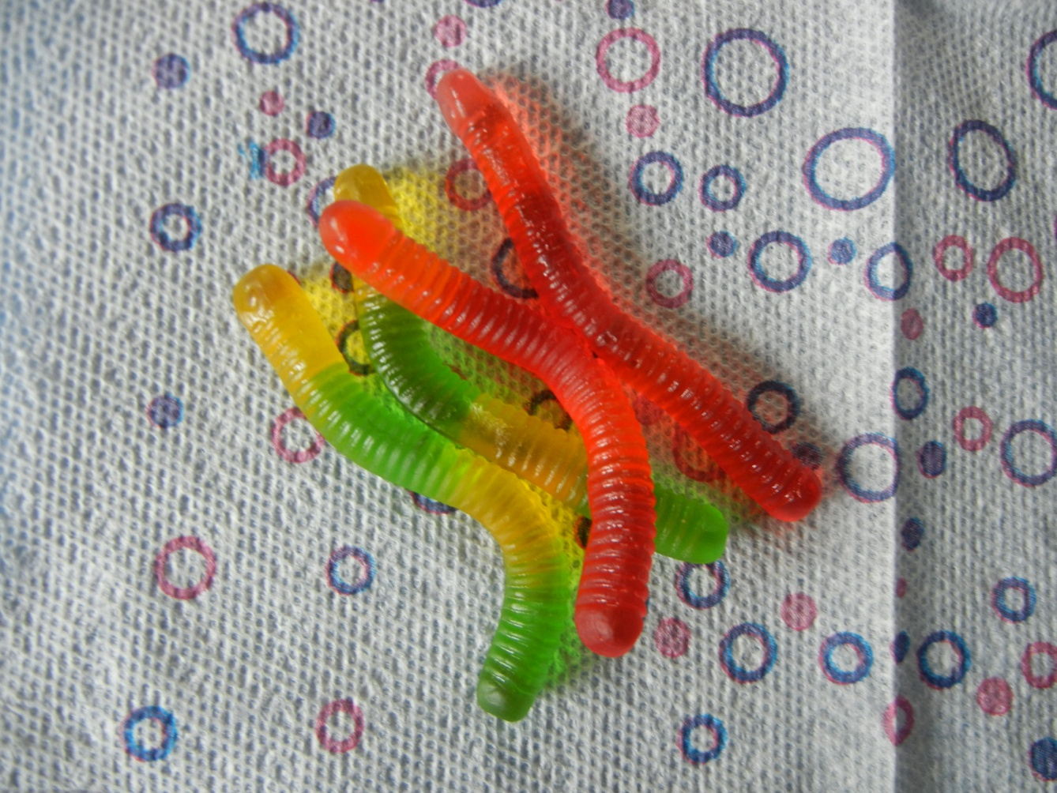
Ask the students what major chromosomal event can happen when tetrads are formed, and guide the discussion to crossing over, and discuss the features of crossing over. Ask the students to complete crossing over in their cells. Demonstrate using sample worms how genetic information can be “swapped” on the worms. Have students bite or cut the worms at the two points of crossing over, called chiasma, until the tips break off, then reconnect the tips to the opposite non-sister chromatid (worm). Allow students time to complete the process of crossing over in their cells, resulting in genetic exchange between homologous chromosomes.
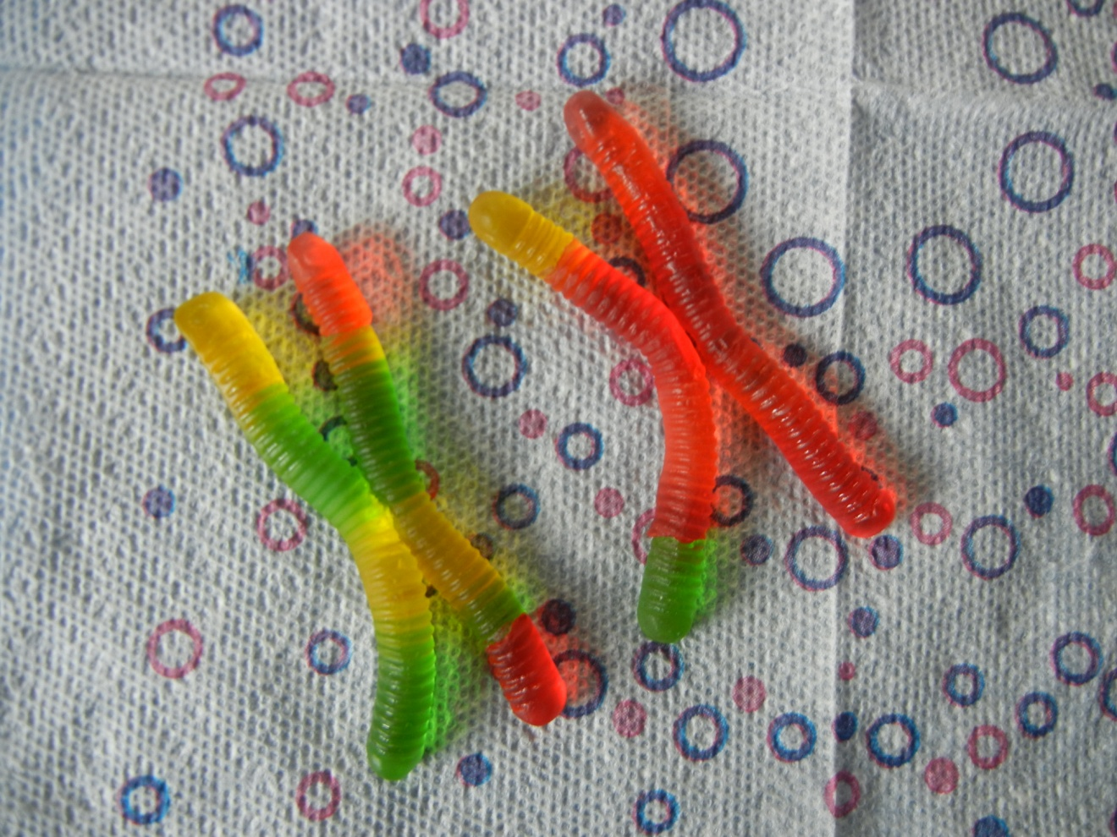
This is an excellent opportunity to discuss genetic linkage with your students. Genetic linkage refers to the tendency for two alleles that are located close together on a chromosome to be inherited together during meiosis. Refer back to the hypothetical examples of “Mom’s red hair, red body, and red feet” that were designated at the beginning of the activity to make this point clear. For example, you might lead students to conclude that “Mom’s red hair” is much more likely to be inherited with “Mom’s red eyes” than “Mom’s red body”.
Next, ask the students to use their schematic outline to determine what major chromosomal movement or event occurs next in meiosis, and to complete that process in their cells. Use different examples to lead the students to metaphase I, as shown by the homologous chromosomes lining up on the metaphase plate. The more prominent crease in the napkin will serve as the metaphase plate.
Often students have differing arrangements of chromosomes along the metaphase plate. See the supplementary instructor guide for examples.
Use the group discussion method to have students reason through what will happen in the resultant gametes under each of the chromosomal arrangements (unequal chromosome information or numbers in each), leading the class to choose the correct arrangement of chromosomes along the metaphase plate. Take time to discuss the importance of the correct arrangement along the metaphase plate and the consequences of improper alignment to follow up on the student conversation.
This may be a good time to discuss the law of independent assortment of chromosomes during meiosis. The law of independent assortment states that chromosomes, or units of inheritance, assort independently during gamete production (meiosis). Adding one or two other “chromosomes” to a projection or model that the whole class can view will help make this concept clearer for students. For example, insert one or two pairs of different colored gummy bears, sour patch kids, etc to the cell and arrange them in different combinations of colors for multiple iterations of the chromosomes lining up on the metaphase plate. Discuss with the students how the “red body” of the worm chromosome has an equal chance of combining with the “orange bear” chromosome as it does with the “blue bear” chromosome.
Ask the students to reference their schematics to determine what happens to the cell next in the process of meiosis, and have students complete this process in their cells. Most students identify the separation of homologous chromosomes to opposite poles of the cell.
Ask the students to reference their schematics to determine what happens to the cell next in the process of meiosis, and have students complete this process in their cells. Discuss cytokinesis and have students rip the napkin along the main crease to model the division of the cell that occurs as cytokinesis.
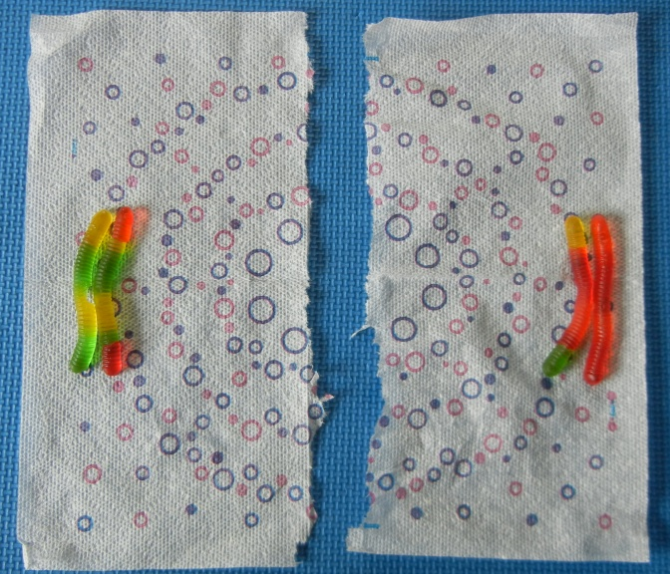
Mitosis 1 is now complete. At this point, take a few moments to discuss the ploidy, chromosome number, total number of chromosomes, total number of chromatids, and total number of DNA molecules present in these cells, and have students fill in the appropriate cells in the table of the companion worksheet.
Ask the students to reference their schematics to determine what major chromosomal event happens next in the process of meiosis, and have students complete this process in their cells. Lead students to metaphase II when the replicated chromosomes are lined up on the metaphase plate. Again, you are likely to get discrepancy among students in the way that they arrange the chromosomes on the metaphase plate. Often students have differing arrangements of chromosomes along the metaphase plate. See the supplementary instructor guide for examples.

As was done during metaphase I, use the group discussion method to have students reason through what will happen in the resultant gametes under each of the chromosomal arrangements (unequal chromosome information or numbers in each) during metaphase II, leading the class to choose the correct arrangement of chromosomes along the metaphase plate. Take time to discuss the importance of the correct arrangement along the metaphase plate and the consequences of improper alignment to follow up on the student conversation.
Ask the students to reference their schematics to determine what happens to the cell next in the process of meiosis, and have students complete this process in their cells. Most students identify the separation of homologous chromosomes to opposite poles of the cell.
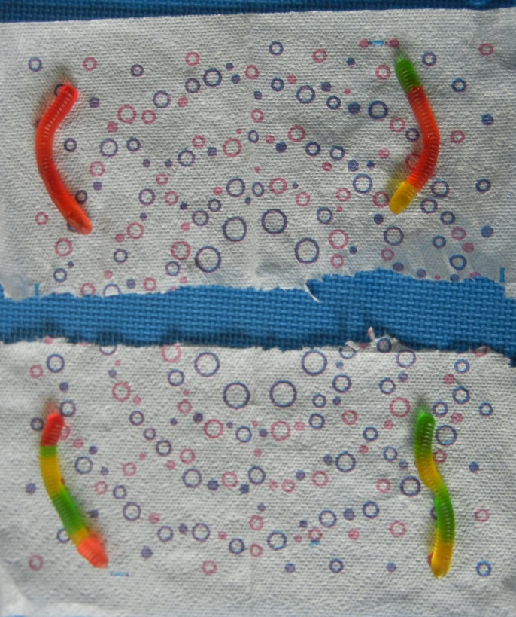
Ask the students to reference their schematics to determine what happens to the cell next in the process of meiosis, and have students complete this process in their cells. Students should rip the cells along the remaining napkin creases to complete cytokinesis.
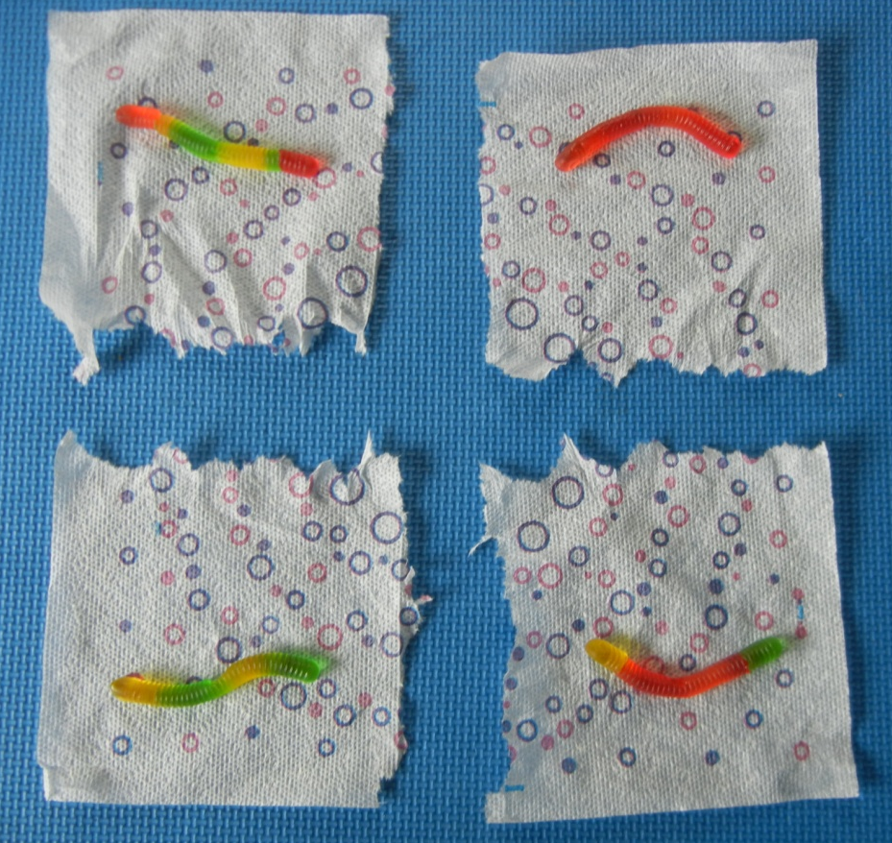
Meiosis II and the process of meiosis is complete. Ask the students what kind of cells they just produced in their bodies, and lead them to discuss eggs and sperm. Take a few moments to discuss the ploidy, chromosome number, total number of chromosomes, total number of chromatids, and total number of DNA molecules present in these cells, and have students fill in the appropriate cells in the table of the companion worksheet. Discuss how the ploidy and numbers of chromosomes and DNA molecules change throughout the process of meiosis.
Now is a good opportunity to discuss how meiosis increases genetic diversity. Poll the class to see how many people have four identical gametes, then three identical gametes, and then two identical gametes. Discuss how each egg or sperm, if they were to complete fertilization, could lead to a child with a different combination of the student’s parent’s traits. Specifically discuss that one child could look identical to the mother and one child could look identical to the father for the traits coded for by this chromosome, but the children produced from the crossed-over chromosomes could have the father’s yellow hair and green feet with the mother’s red body, or another child could have the mother’s red hair and red feet with the father’s green body.
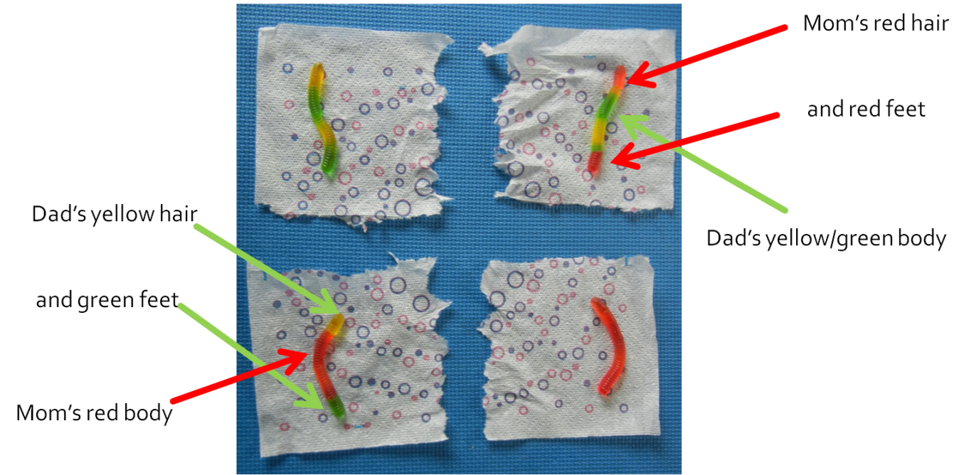
Next have the students view the gametes of a neighboring student of opposite sex and imagine how the child might look when an egg of one student is fertilized by the sperm of another. The child could have the one grandparent’s red hair, one grandparent’s orange body, and a different grandparent’s green feet, depending on allelic relationships such as dominance or epistasis. At the conclusion of the activity, students are permitted to eat their gametes.
Part 4: Demonstration: Mistakes in Meiosis (3-5 minutes)
If desired, this activity can also be used to help students visualize how mistakes in meiosis can lead to cell death or chromosomal abnormalities. It is recommended to complete the process of meiosis separately from the discussion of mistakes in meiosis. Using a document camera or prepared powerpoint slides depicting gummy worm arrangements is recommended for this portion of the exercise if class time or materials are a limiting factor for your course. A sample powerpoint containing slides on mistakes in meiosis is provided.
Ask students what happens if homologs fail to separate properly during meiosis I. Discuss and display nondisjunction, explaining how it leads to unequal numbers of chromosomes in daughter cells.
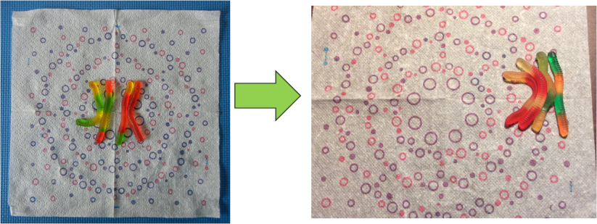
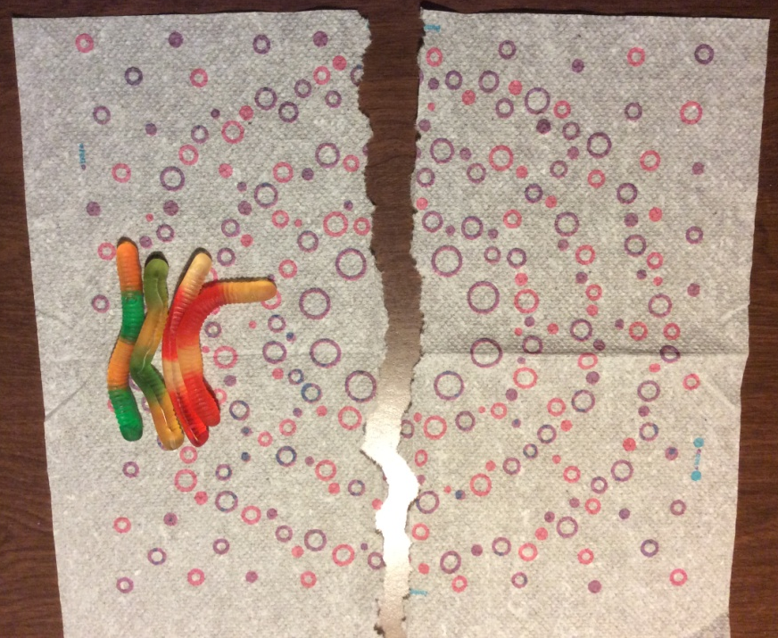
Engage students in a discussion about how this compares to nondisjunction during meiosis II, and demonstrate or display how this can lead to unequal numbers of chromosomes in gametes after meiosis II is complete.
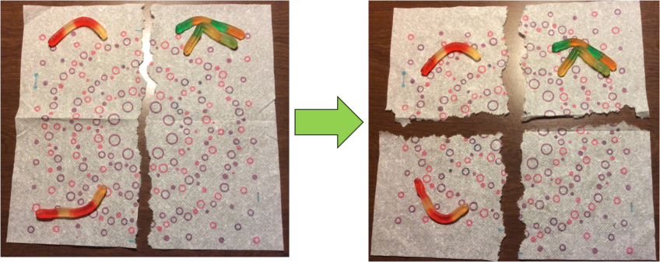
Apply these instances of nondisjunction to the potential consequences of chromosomal abnormalities in humans, including miscarriage, Down’s syndrome and Turner’s syndrome.
Part 5: Quantitative Reasoning Application Questions (5-10 minutes)
This modeling of meiosis can also be used to help students visualize how mistakes at different points in meiosis can lead to different distributions of chromosomal abnormalities. Four examples of quantitative reasoning application questions are included below. Note: these questions were modeled after textbook questions in Freeman et al., Biological Science, 5th edition.
When one of Joe’s human gonadal cells undergoes meiosis to form sperm cells, chromosomal nondisjunction occurs at chromosome 21 during meiosis I. How many of Joe’s gametes produced by this gonadal cell might lead to a child with trisomy 21 (Down’s syndrome) if they fertilize an egg?
a.1
b.2
c.4
d.8
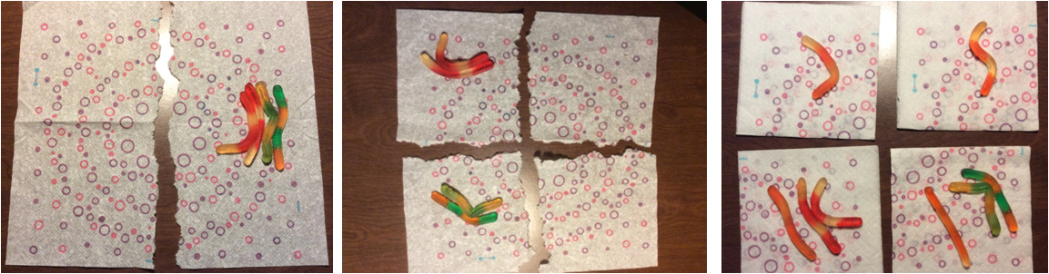
(Answer: b.2)

The cells that produce sperm in humans contain 46 chromosomes. If one of these cells undergoes meiosis to form sperm cells, and chromosomal nondisjunction occurs in chromosome 22 during meiosis I, how many chromosomes are in each of the resulting sperm?
a.23, 23, 22, and 24
b.24, 24, 23, and 23
c.24, 24, 22 and 22
d.45, 45, 47 and 47
(Answer: c.24, 24, 22 and 22)
When one of Jane’s human ovary cells undergoes meiosis to form egg cells, chromosomal nondisjunction occurs on the X chromosome during meiosis II. How many of Jane’s gametes produced by this ovarian cell might lead to a child with monosomy of the X chromosome (Turner syndrome) if they are fertilized?
a.1
b.2
c.4
d.8
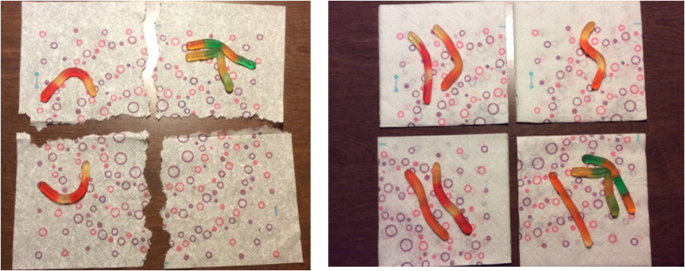
(Answer: a.1)

The cells that produce sperm in humans contain 46 chromosomes. If one of these cells undergoes meiosis to form sperm cells, and chromosomal nondisjunction occurs in chromosome 22 during meiosis II, how many chromosomes are in each of the resulting sperm?
a.23, 23, 22, and 24
b.22, 22, 23, and 23
c.24, 24, 22 and 22
d.45, 45, 47 and 47
(Answer: a.23, 23, 22 and 24)

References
Freeman, S., Allison, L., Black, M., Podgorski, G., Quillin, K., Monroe, J., and Taylor, E. (2014). Biological Science. 5th ed. Pearson Education, Inc.

